**Happy Trip**

**Software Requirements Specification**

**For Iteration 3**

**Version 1.1**

**Produced by:**

**Pratian Technologies (India) Pvt. Ltd**

**Bangalore**

Revision History

|  |  |  |  |
| --- | --- | --- | --- |
| **Date** | **Version** | **Description** | **Author** |
| 08 June 2013 | 1.0 | Initial Draft | Ayaskant Sahu |
| 22 June 2013 | 1.1 | Changes as per clarification log | Ayaskant Sahu, Priyanka Grover |

Table of Contents

Revision History 2

Table of Contents 3

1Introduction 4

1.1Definition 4

1.2Specification Objectives 4

1.3Intended Audiences 4

1.4References 5

1.5Specification Overview 5

2System Overview 6

2.1System Usage 6

2.2Context 7

2.2.1Human Actors 7

2.2.2External Data Repositories 8

2.2.3External Hardware 8

2.2.4External Networks 8

2.2.5External Systems 8

3System Operational Requirements 10

3.1Use Case Diagrams 10

3.1.1HappyTrip System diagram 10

3.1.2User Module 10

3.1.3Admin Module 11

3.2Functional Requirements: 11

3.2.1User Module 11

3.2.1.1Book Hotel Room – [Both registered and non-registered users] 11

3.2.1.2Cancellation 15

3.2.1.3My Hotel Bookings (Hotel Booking History) 16

3.2.2Admin Module 16

3.2.2.1Maintain Hotel information 17

3.2.2.2Add Hotel Room 17

3.2.2.3Delete Hotel 18

3.2.2.4Error Handling 19

3.2.3Non Functional Requirements 20

3.2.3.1Browser compatibility 20

3.2.3.2Performance Requirements 20

3.2.3.3Session Management & Security 20

3.2.3.4Usability 20

4Architecture and Design 21

6Future Enhancements 23

7References 24

**Table of Figures**

# Introduction

The Software Requirements Specification (SRS) for the application HappyTripis intended to detail out the requirements design & implementation approach outlined for the same.

## Definition

This document will be referred as the absolute final requirements specification and it is this requirements work product that formally specifies the requirements of the Happy Trip.

## Specification Objectives

This software requirements specification has the following objectives:

* To provide an overview of the application’s context and capabilities.
* To formally specify the associated:
* Operational requirements
* Informational requirements
* Architecture and Design
* To document any future planned enhancements
* To document any open issues, major things to be completed, and assumptions.

## Intended Audiences

This system requirements specification has the following intended audiences:

* **Architecture Team& Tech Leads -** to drive and validate the system architectures.
* **Test Leads -** to understand the scope of the application to be delivered.
* **Configuration Mgt. Team -** to drive the design of the hardware components and engineering environment
* **Test Engineers Team -** to generate test artifacts.
* **Orchard Team** - to manage project scope and schedule project activities.
* **Dev. Engineers Team -** to drive the design of the software components for implementation (coding and related activities) purpose.
* **Any other stakeholders not explicitly mentioned above.**

## References

Customer Requirement Document:

* Happy Trip Project Requirement.pdf

## Specification Overview

This SRS is organized into the following sections:

* **Introduction:** This introduces the SRS for Happy Trip to its readers.
* **System Overview:** This provides a high level description of Happy Trip system including its definition, functions, context, and typical usage.
* **System Operational Requirements:** This specifies the system’s operational (functional) requirements
* **Architecture and Design:** This specifies required architecture and design to be treated as requirements.
* **Future Enhancements:** This section will specify the planned future enhancements.
* **Appendices:** This defines ancillary information including open issues and TBDs, etc.

# System Overview

Happy Trip is one of the leading companies in the world which provide services in the Travel domain. Happy Trip has decided to launch a portal for users to book flight tickets online for travel across India. This portal will also have administrative module to maintain flights & their schedules, inventory etc.

This portal would essentially have 2 modules:



1. User Module – All user related operations, like, features to searching, booking and cancelling hotels online.
2. Admin Module – To manage hotels in a city, rooms in each hotel and to view all hotels in a city.

## System Usage

* Search hotels
* Book hotel room.
* Add Hotel Information
* Add rooms for each hotel
* View hotels in specific city.
* Delete hotels from specific city.

## Context

The subsection uses context diagrams to document the context of the Happy Trip in terms of the external actors, data repositories, hardware, networks, software, and systems with which it interacts.

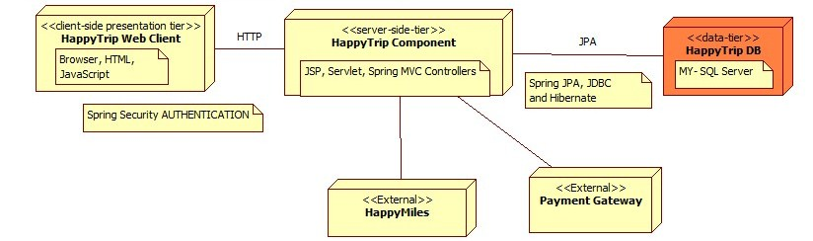

Figure : HappyTrip Context Diagram

### Human Actors

HappyTrip interacts, either directly or indirectly, with the following significant human actors

* Guest Users:
  + Who uses the system to search flight with desired details, book ticket (with or without insurance)
  + Who is interested in registering to the portal



* Registered Users:
  + who uses this system to search hotels, book rooms in a hotel and cancel bookings.



* Admin:
  + Who uses the system to add hotels, manage rooms, delete hotels and view hotels per city



### External Data Repositories

None

### External Hardware

None

### External Networks

None

### External Systems

1. Credit Card Payment Gateway

# System Operational Requirements

The section of the SRS specifies the system’s operational requirements in terms of a High Level Design diagram.

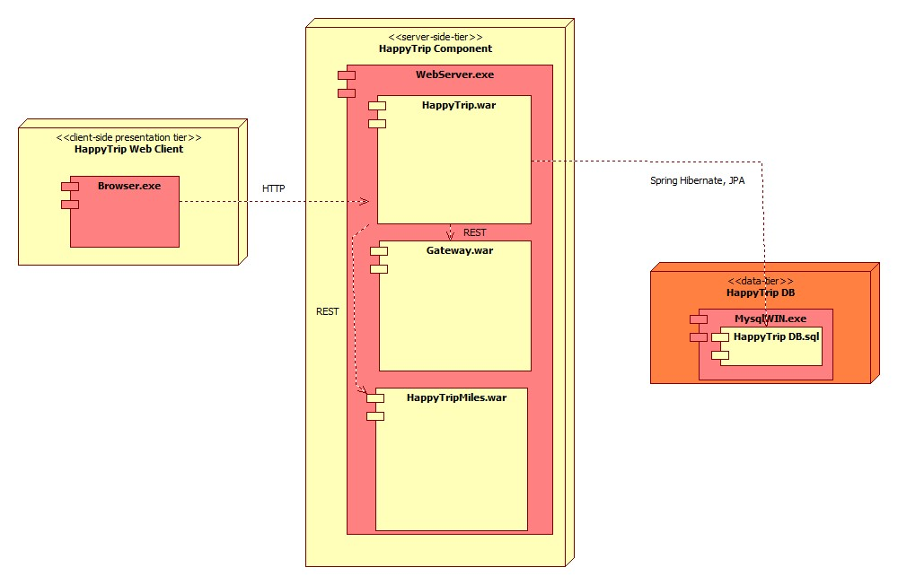

Figure : HappyTrip High Level Design Diagram

## Use Case Diagrams

### HappyTrip System diagram

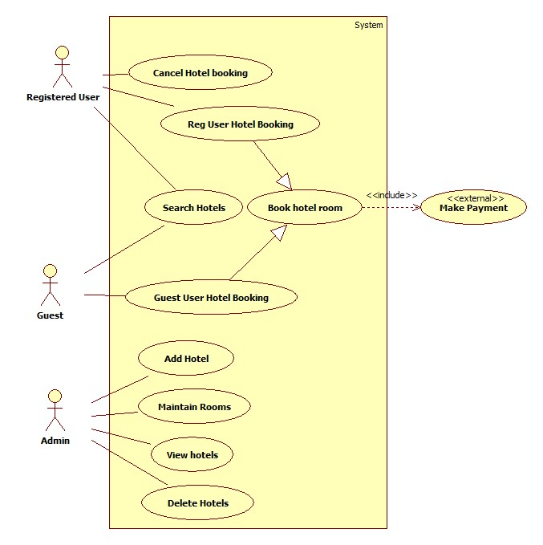

### User Module

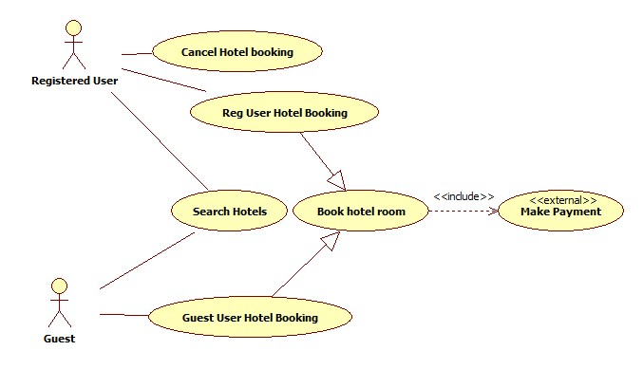

### Admin Module

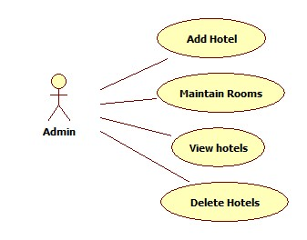

## Functional Requirements:

### User Module

#### Book Hotel Room – [Both registered and non-registered users]

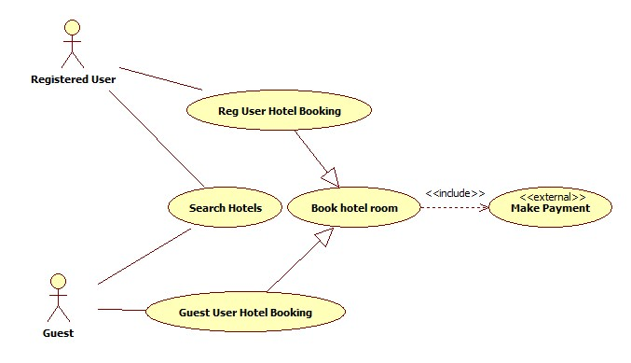

User can book hotel rooms on the portal with or without registration

* 1. First, user has to enter travel information and to search the hotel available for his/her search criteria
  2. Information to be given on search page
     1. City Name
     2. Date Of Check-in
     3. Date of Checkout
     4. No Of Persons – In terms of No. of Adults, Children & Infants – default selection: 1 Adult only
     5. Type of Room- Default Selection is “Budget”
  3. Checks should be done to ensure that the user don’t attempt to book rooms beyond 3 months from the current date.
  4. Checks should also be done to ensure that there are rooms available matching the criteria else no result found message to be shown
  5. Only cities having a hotel in them should be listed in the autosuggest.
  6. If there are hotel rooms found for the above mentioned information, then all those hotel rooms along with each one’s details should be listed
  7. Information to be displayed for each hotel room would be
     1. City
     2. Date Of Check-in
     3. Hotel Name
     4. Hotel Address
     5. Room Type
     6. Cost of the room per day.
  8. Results should be sorted in the order of price, with Lowest price on top From here user would select an appropriate hotel.
  9. Upon selection, user can click “Book” button & he should be navigated to next page where he would be able to enter the below mentioned information to book the hotel room
     1. Title (Mr, Ms)
     2. Full Name
     3. Gender (Male/Female)
     4. Date Of Birth
     5. Mobile No
  10. If registered user has logged in, then the application should prefill all these details from his/her profile
  11. User must enter the details of additional passengers who will be travelling along. For each additional passenger, the following details must be provided.
      1. Title
      2. Name
      3. Gender
      4. Date of birth
  12. All fields mentioned above would be mandatory. After entering all the information, a confirmation screen should be provided where user is shown all the details regarding the room to be booked
      1. Full Name – First passenger’s name for guest user transaction & Registered user’s name for registered user
      2. Date Of Birth
      3. Date Of check-in
      4. Time of check-in – Fixed as 12 PM for all hotels
      5. Date Of checkout
      6. Time of checkout – Fixed as 10 AM for all hotels
      7. Hotel Name
      8. City
      9. Address
      10. No Of Occupants
      11. Room Description
      12. Total Price of the hotel booking.

** Please note, the check-in & check-out time are implemented as fixed for this iteration. The future release of application will allow admin to add these details to the hotel.

* 1. If the user confirms these details, he should be proceeded towards the page to Accept payment from the user
  2. Payment is made via a payment gateway, which would be hosted on a separate environment & HappyTrip is integrated with it to validate the user details
  3. In this page, user has to enter the payment related information like
     1. Credit Card No – 16 digit number
     2. CVV No – 3 digit number
     3. Credit Card Type (Visa/MasterCard)
     4. Card Holder Name
     5. Expiry Date – Month and Year
     6. Total Amount to be debited should be displayed
  4. If payment process fails, user has to be informed about the same and should be asked to retry the booking
  5. If payment is successful, a unique booking no is generated and displayed to the user along with detailed travel information as below:
     1. Full Name – First passenger’s name for guest user transaction & Registered user’s name for registered user
     2. Date Of Birth
     3. Date Of check-in
     4. Time of check-in – Fixed as 12 PM for all hotels
     5. Date Of checkout
     6. Time of checkout– Fixed as 10 AM for all hotels
     7. Hotel Name
     8. City
     9. No Of Occupants
     10. Room Type
     11. Booking Reference No
     12. A list of passengers, with the following information displayed row-wise for each traveler in this booking
         1. Title
         2. Name
         3. Gender
         4. Date of Birth
     13. Total Price of the booking.
  6. This Data of successful transaction should be stored for the booking & it is reflected in the My Hotel Bookings section as well

#### Cancellation

* 1. Only, a registered user can cancel an upcoming stay from his hotel booking history (“My Hotel Bookings” section)
  2. A room can only be canceled if at the cancellation time, the time remaining for its check-in is at least 1 day, else this option will not be available for the booking.(For example: If a booking is made for tomorrow, then this booking can be cancelled up until 0000 hrs of tomorrow. Once tomorrow’s date starts it cannot be cancelled)
  3. A cancelation fee of INR 750/- is charged for per booking (irrespective of the room type), in the booking transaction being cancelled. If the booking amount is less than or equal to Rs 750, nothing should be refunded back
  4. Once user confirms cancellation of the booking, he should get a cancellation process success message on the next page, with the amount refunded for the transaction.
  5. Refund payment is credited back into the Credit card (used while booking) account of the user and can only be tracked by making bookings subsequently with the refunded amount added to account balance.

#### My Hotel Bookings (Hotel Booking History)

1. The Booking History can be viewed only by a registered user in My Hotel Bookings section
2. This page will show details of the journeys completed and the upcoming journeys
3. The Booked Trips listing for the user displays details for each booking transaction of the logged on user, as follows:
   * 1. Booking ID
     2. Hotel Information – Hotel Name, Room Type
     3. Date of Booking
     4. Total amount paid for this booking
     5. City
     6. Status of the booking –Lapsed, Cancelled, Cancel (Link to cancel booking)
4. “Cancel” Option should be shown only for an upcoming booking, which is scheduled atleast 1 day later than the current time

### Admin Module

Admin will be able to manage hotels and rooms through the admin module. Admin can login using his/her login id and password. These operations have to be carried out only by the admin and travel user should not have the access to any of the admin modules

#### Maintain Hotel information

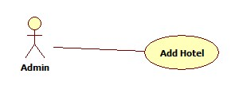

* 1. Admin should be able to maintain hotels with the following modules
     + Add a new hotel
       1. Admin can add a hotel by specifying the following fields
          1. City – To be chosen from a dropdown, which is the same as Cities maintained in the application through “Add City” & “View/Edit City” Modules
          2. Hotel Name
          3. Star rating – to be chosen from a dropdown
          4. Address
          5. Email
          6. Phone no.
       2. Hotel Name has to be unique and less than 255 characters.
       3. All fields are mandatory
       4. Once added, this hotel should be available in the Add Hotel rooms module’s dropdown for Hotels

#### Add Hotel Room

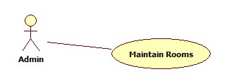

* 1. Admin should be able to add -new Rooms to a hotel with following details
     + Hotel* - List of existing hotel in the system, alphabetically sorted in ascending order - First Hotel name should be selected by default
     + Room type – To be populated in a dropdown from database. It can be Budget, Suite & Deluxe.
     + Cost per day
     + Number of rooms
  2. Once added successfully, the hotel should be available for search.
  3. If the room type is already available in the chosen hotel, the number of rooms are updated for the same hotel in the same category and the price for all the rooms are updated as per the latest room add.
  4. All fields are mandatory

#### Delete Hotel

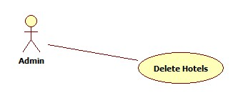

* + - Admin can view all the hotels available in a particular city.
    - Cities should be listed in a dropdown.
    - Hotels should be listed in ascending order of their name.
    - Admin can delete a hotel by clicking on the delete button next to a hotel name.
    - A hotel with future bookings can’t be deleted
    - In case of above scenario, an error message will be shown on screen.
    - All bookings related to the deleted hotel will be deleted.
    - The hotel should not show up in future search.

#### Error Handling

#### 

* All Validation Errors and exceptions occurring in the application should be handled & a message should be displayed by the system for the same.
* The system should have graceful exits defined for errors & exceptions

### Non Functional Requirements

#### Browser compatibility

The application will be best viewed in Google Chrome browser

#### Performance Requirements

The performance requirements for this application are currently limited to benchmarking the response time of the application for mainly two pages, as follows:

1. Home Page: The maximum time taken for home page to load, with 50 concurrent users trying to access this page, should not exceed 10 seconds.
2. Search Results Page: For any search criteria specified, which has at max 10 matching schedules, the time taken for search results page to load, with 50 concurrent users trying to access this page, should not exceed 30 seconds

#### Session Management & Security

The requirements for session management & security in this application are related to roles defined in the application. As detailed above, the three actors, Guest User, Registered User & Admin User, should have session management with respect to the user role. At no time, one user should be able to view the other user’s session related data, features & access privileges.

#### Usability

This subsection specifies the following requirements concerning the ease with which the system can be used.

* 1. Consistent Web based UI
  2. Easy to use and navigate
  3. Intuitive – With Tool tips
  4. Colors should be pleasant to the eye of the user
  5. Provide easy access by implementing Ajax and avoid page refresh wherever possible

# Architecture and Design

The section documents the major architecture and design of the system.





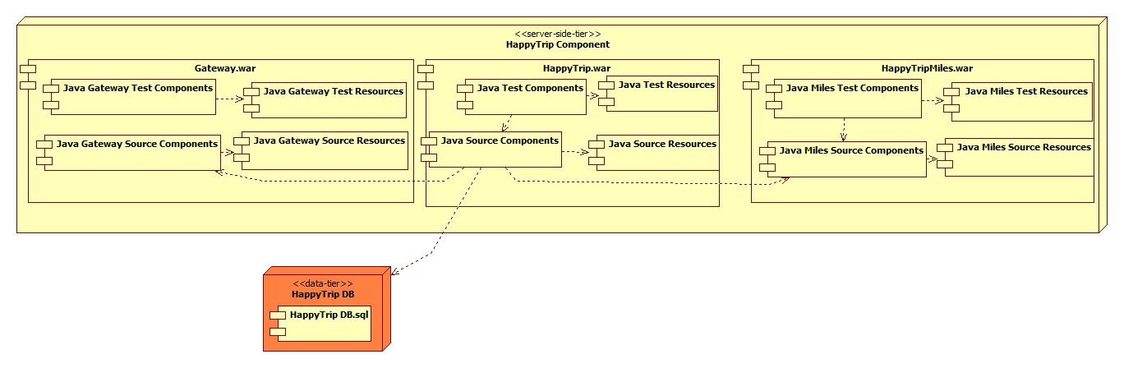

# Future Enhancements

The section documents the following envisioned future enhancements:

* The HappyTrip in future will support IE
* There is plan to create a mobile version of the application, but a feasibility study needs to be done. Also we need to analyze the usage patterns

# References

The section documents the following references useful to understand this document:

1. “HappyTrip.com Project Requirement.pdf”
2. “HappyTrip-Architecture.uml”
3. “HappyTrip-Booking Activity.uml”
4. “HappyTrip-UseCase.uml”
5. “data model.png”